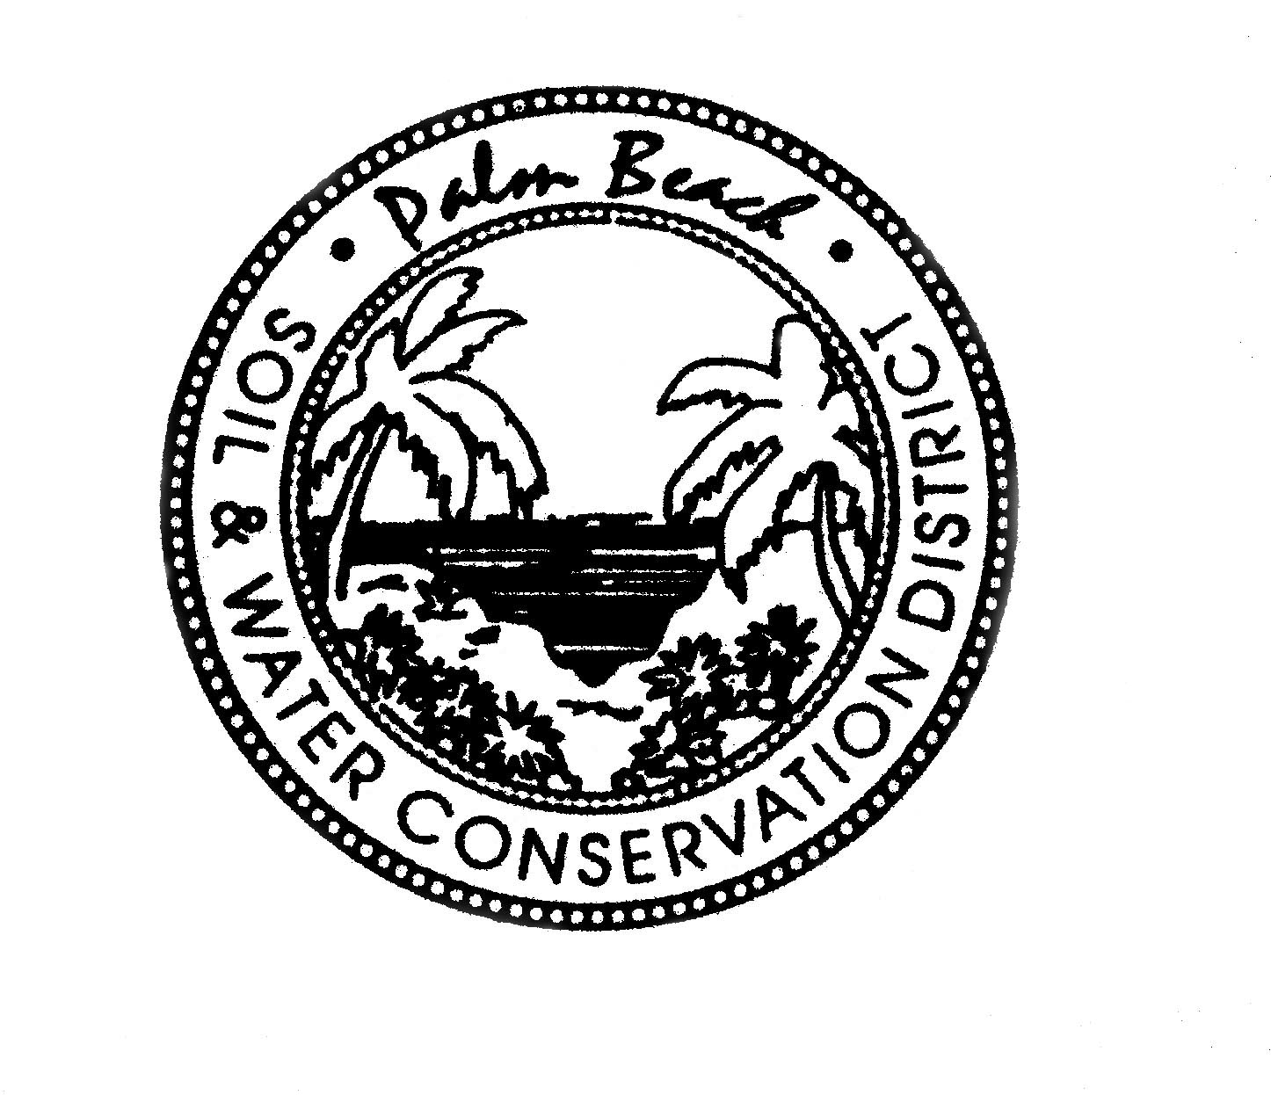
Palm Beach Soil & Water Conservation District
420 S. State Road 7* Suite 162 * Royal Palm Beach, FL 33414
Office 561-792-2727 x 3

Board Meeting Schedule
Fiscal Year 2020 – 2021

The District board approved the following meeting dates on September 24, 2020 and revised on February 25, 2021.

Please visit www.pbswcd.org for meeting details or contact the office.

October 22, 2020 @ 5:30PM

November 19, 2020 @ 12:00 PM

January 28, 2021 @ 5:30 PM

February 25, 2021 @ 1:00 PM – Summit Library

March 25, 2021 @ 1:00 PM – Cooperative Extension Exhibit Hall

May 27, 2021 @ 1:00 PM – Cooperative Extension Exhibit Hall

June 24, 2021 @ 1:00 PM – Mounts Auditorium

July 22, 2021 @ 1:00 PM -– Mounts Auditorium

August 26, 2021 @ 1:00 PM - Cooperative Extension Exhibit Hall

September 23, 2021 @ 1:00 PM – Mounts Auditorium

Cc:
County Clerk, 301 N. Olive Ave., WPB, FL 33402
PB Governmental Center, Public Affairs Office, 301 N. Olive, WPB, FL 33402
PB Governmental Center, 11th Fl. Reception, 301 N. Olive, WPB, FL 33402
County Extension Service, 559 N. Military Trail, WPB, FL 33415
Office of Ag. Water Policy, c/o SFWMD PO Box 24680, WPB, FL 33416 Attn: Rebecca Elliot, MSC7210 PBSWCD Board
Palm Beach Post

