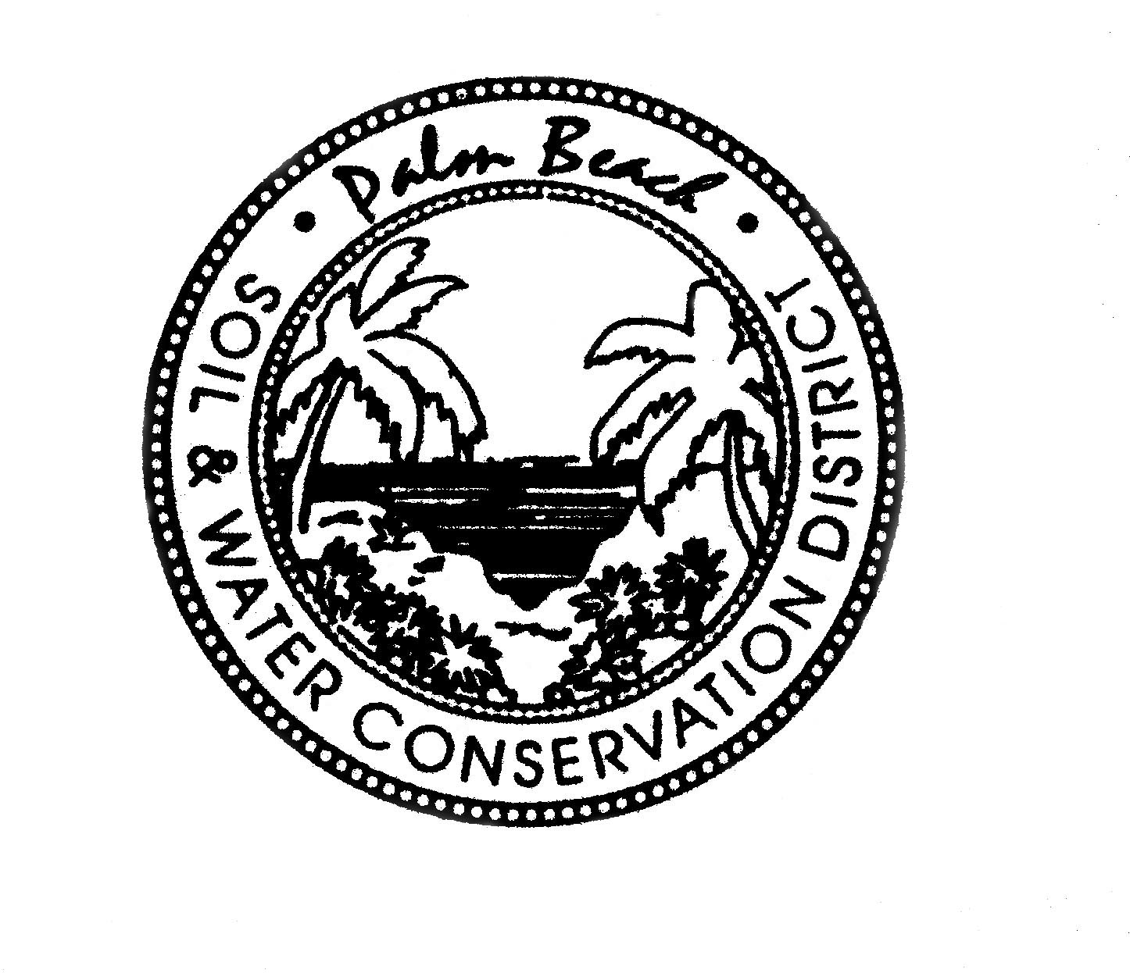

AGENDA

PALM BEACH SOIL & WATER CONSERVATION DISTRICT
BOARD OF GOVERNING SUPERVISORS MEETING
559 N. Military Trail, West Palm Beach, FL 33415
March 25, 2021 at 1PM

Part of this meeting may be conducted as a video or teleconference in order to permit maximum participation of Board members (Section, 120.54(5)(b)2). The Board may take official action at this meeting on any item appearing on this agenda and on any item that is added to this agenda as a result of a change to the agenda approved by the presiding officer of the meeting pursuant to Section 120.525, Florida Statutes. The order of items appearing on the agenda is subject to change during the meeting and is at the discretion of the presiding officer.

1. CALL TO ORDER
A Roll Call
B Invocation
C Pledge of Allegiance

D Agenda Approval

2. OATH OF OFFICE – SEAT 1

- SECRETARY’S REPORT
*Approval of the February Meeting Minutes

- TREASURER’S REPORT

- STAFF REPORTS
A David DeMaio
B Laura Bloom
C Ramon Santiago
D Robert Perez

- USDA/NRCS

OLD BUSINESS
- *SFWMD Contract

NEW BUSINESS
8. *Audit

DISCUSSION ITEMS

PUBLIC COMMENTS

ADJOURNMENT
*DENOTES ACTION ITEM

