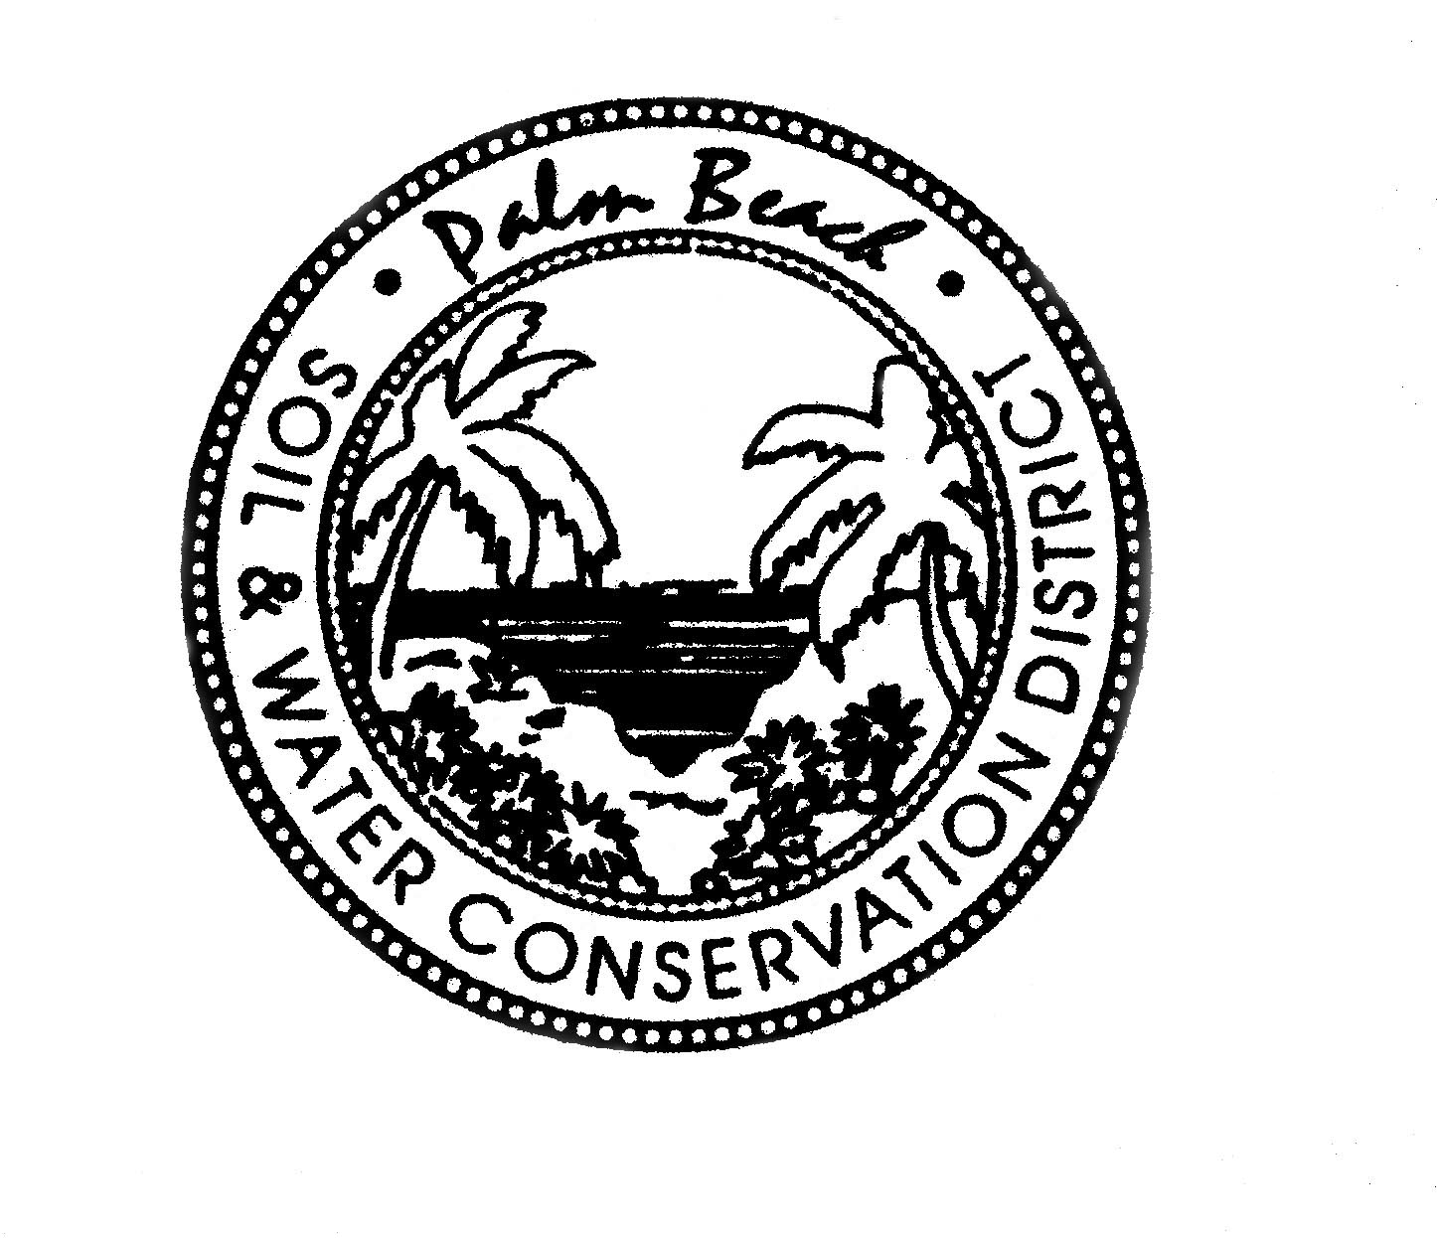

AGENDA

PALM BEACH SOIL & WATER CONSERVATION DISTRICT
BOARD OF GOVERNING SUPERVISORS MEETING
420 S. State Road 7, Royal Palm Beach, FL 33414
September 24, 2020
12:00 PM

All or part of this meeting may be conducted as a teleconference in order to permit maximum participation of Board members. The Board may take official action at this meeting on any item appearing on this agenda and on any item that is added to this agenda as a result of a change to the agenda approved by the presiding officer of the meeting pursuant to Section 120.525, Florida Statutes. The order of items appearing on the agenda is subject to change during the meeting and is at the discretion of the presiding officer.

CALL TO ORDER
A Roll Call
B Invocation
C Pledge of Allegiance

D Changes to Agenda

- SECRETARY’S REPORT
*Approval of July Meeting Minutes

- TREASURER’S REPORT

- STAFF REPORTS
A David DeMaio
B Laura Bloom
C Ramon Santiago
D Robert Perez

- USDA/NRCS

NEW BUSINESS
- *Draft Budget FY 20/21
- *Board Meeting Dates FY 20/21

OLD BUSINESS

DISCUSSION ITEMS

PUBLIC COMMENTS

ADJOURNMENT *DENOTES ACTION ITEM

